**APA Thesis Formatting for Thesis and Dissertation**

On the process in formatting thesis/dissertation:

1st step: Click on the *Paragraph marks* icon under the *paragraph* ribbon or simply *press the (CTRL + SHIFT + 8)* to activate and to be able to view the format of the manuscript.

*Additional tip:* Check if the *ruler* is activated if not Go to *View* tab and *check the Ruler.*

*Additional Tip:* Check the Paragraph spacing and indention by clicking on the *Page layout* tab and the *spacing and the right indent* should always be 0.

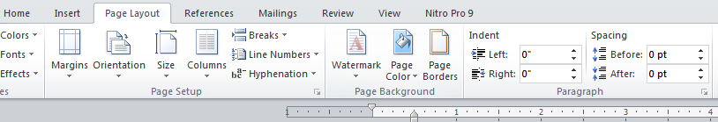

2nd Step: Double Click the header and go to *Page Layout* and *check the margin* used in the manuscript, the margin of thesis/dissertation should be the size as seen below:

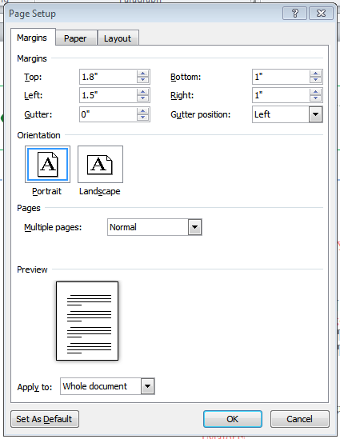

3rd step: Go to *Design* tab and check if the *position* of the header and footer is 0.5 to make the margin more accurate. After checking on this part, click the *Close Header and Footer* to start formatting on the first page.

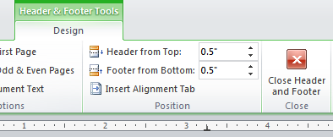

4th step: Check the First page/Title page if it follows the correct format based on the template.

5th Step: Copy or check *the Recommendation sheet* and *Approval sheet* if the format is correct based on the template. The researchers should also insert the information needed or just simply replace the red highlighted words. Ex. [Name of Adviser]

6th step: In *Table of Contents* go to *Home* tab and Click the *dialog box* on the *Paragraph ribbon* as seen below:

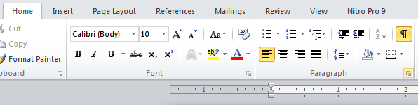

Click on *Tabs*

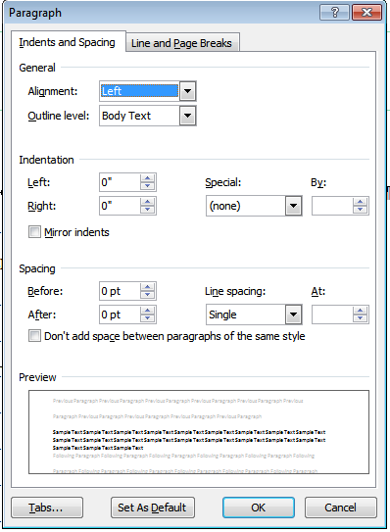

And input these values on tabs as seen below:

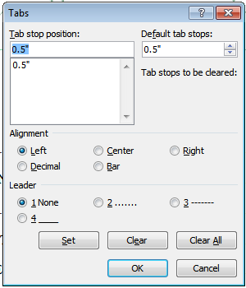 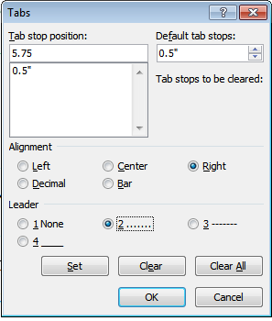

After setting these values, you can check the ruler if the marks was successfully entered if the ruler looks like this:



For *List of Tables, Figures and Appendices* same format with the template.

7th step: In abstract, just copy the format and replace the red highlighted words with the information needed.

8th step: For the Chapters format:

Make sure it is *double spaced and justified* and no extra spaces on the spacing. *[Go to Page Layout and check the Paragraph ribbon]*



If there is a numberings on a topic/sub topic, follow the steps below:

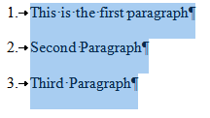



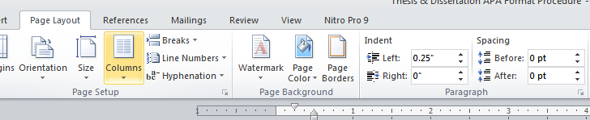

If there is a subtopic follow these steps:

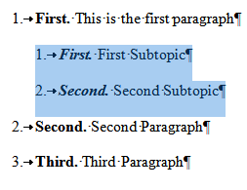



The number of the Subtopic should align with the First letter of the Topic.

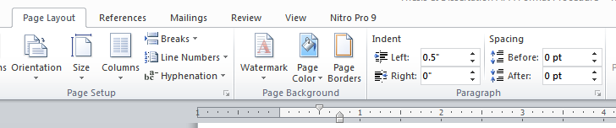

*Tip:* As long there is a sub topic in a topic the indention should be continuously as 0.25, 0.5, 0.75, 1 and so on so forth.

9th step: For formatting *Tables*:

Not bold and italicized

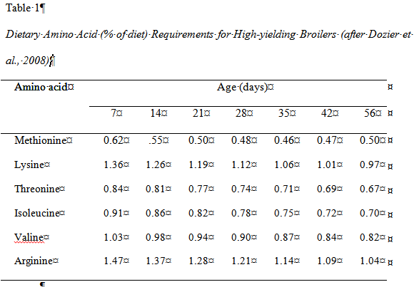

Italicized and not justified

For the table format:

Select/Highlight or click the cross shaped beside the table.

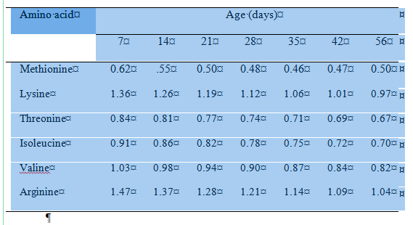

Go to *Design tab* and click on this type of table format:

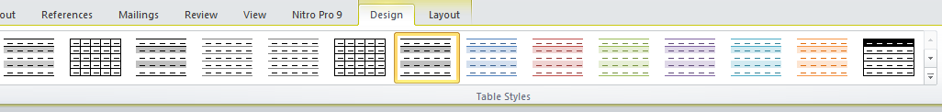

Go to *Shading and Select white*

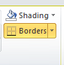

Go to *Layout tab* and click on properties

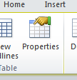

The properties should be look like this:

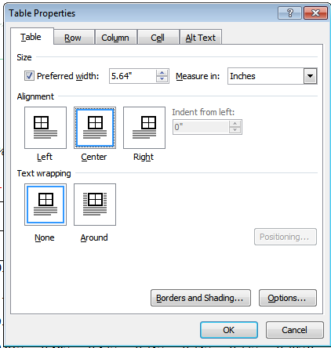

And click ok and after that press CTRL+B or click the Bold Icon to unbold all the text inside the table.

*Note:* The table should not be bold.



*Important Reminder:* In numbering a table, it should be continuously even the tables on the appendices so that the numbering/s of the table are consistent. Ex. Table 1, Table 2… and etc.

Avoid using Table 1a, Table 1.1.. and so on so forth.

*10th step:* In formatting *figures* such as picture/photo/Graph and etc. follow these steps:

Click on the picture and go to *Format tab*

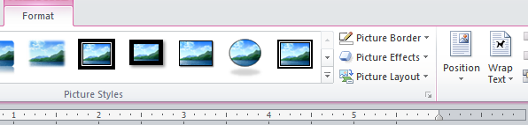

Click on the *Position* and Select *In line with text* and the figure should be *Centered*

*Alternative step:* *Click on the figure* and *right click* go to *Wrap text* and *select in line with text* and the picture/graph should be *Centered*

*Important Reminder:* In numbering a figure, it should be continuously so that the numbering/s of the figure is consistent. Ex. Figure 1, Figure 2… and etc.

Avoid using Figure 1a, Figure 1.1.. and so on so forth.

*11th Step:* On *Appendices*, Check the Title if it uses Appendix A, B, C, D. Avoid using Appendix 1, 2, 3…

*12th step:* In *References*, Use single space and the indention should be Right: 0.5 and Left: 0 and leave a one enter/space before another reference.

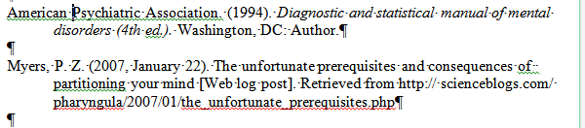

*13th step:* On Curriculum Vitae just follow the format on the template and insert the specified information needed.

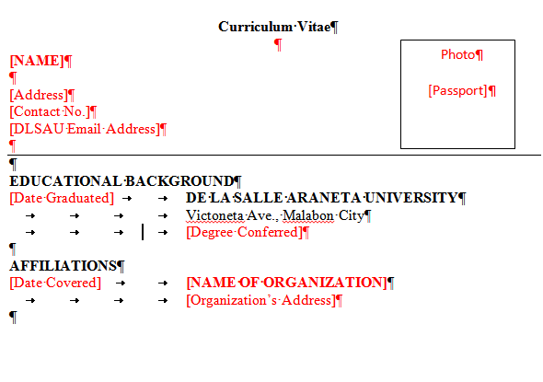

**Help Zone:**

Keyboard Shortcuts

|  |  |
| --- | --- |
| To do this | Press |
| Go to "Tell me what you want to do" | Alt+Q |
| Open | Ctrl+O |
| Save | Ctrl+S |
| Close | Ctrl+W |
| Cut | Ctrl+X |
| Copy | Ctrl+C |
| Paste | Ctrl+V |
| Select all | Ctrl+A |
| Bold | Ctrl+B |
| Italic | Ctrl+I |
| Underline | Ctrl+U |
| Decrease font size 1 point | Ctrl+[ |
| Increase font size 1 point | Ctrl+] |
| Center text | Ctrl+E |
| Left align text | Ctrl+L |
| Right align text | Ctrl+R |
| Cancel | Esc |
| Undo | Ctrl+Z |
| Re-do | Ctrl+Y |
| Zoom | Alt+W, Q, then tab in Zoom dialog box to the value you want. |
| Paragraph Marks | CTRL + SHIFT + 8 |